Devin Hardy

00076619

CS423

Skeleton

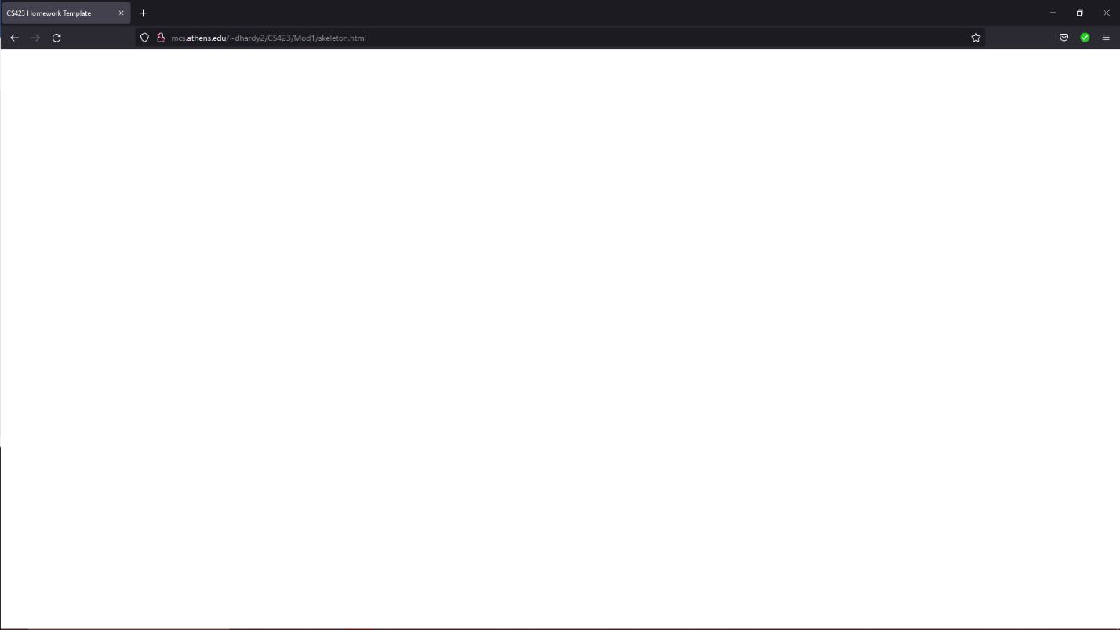

<!DOCTYPE html>

<HTML>

<HEAD>

<TITLE>CS423 Homework Template</TITLE>

<SCRIPT

TYPE="text/javascript"

SRC="../libs/three.js">

</SCRIPT>

<STYLE>

body {

margin: 0;

overflow: hidden;

}

</STYLE>

</HEAD>

<BODY>

<DIV ID="WebGL-output">

</DIV>

<!-- Scripts that we use for running things -->

<SCRIPT TYPE="text/javascript">

// Put the bulk of what we do in the onlad handler

// for the window.

funcion init() {

// Put Three.js stuff here.

}

window.onload = init

</SCRIPT>

</BODY>

</HTML>

Simple Scene

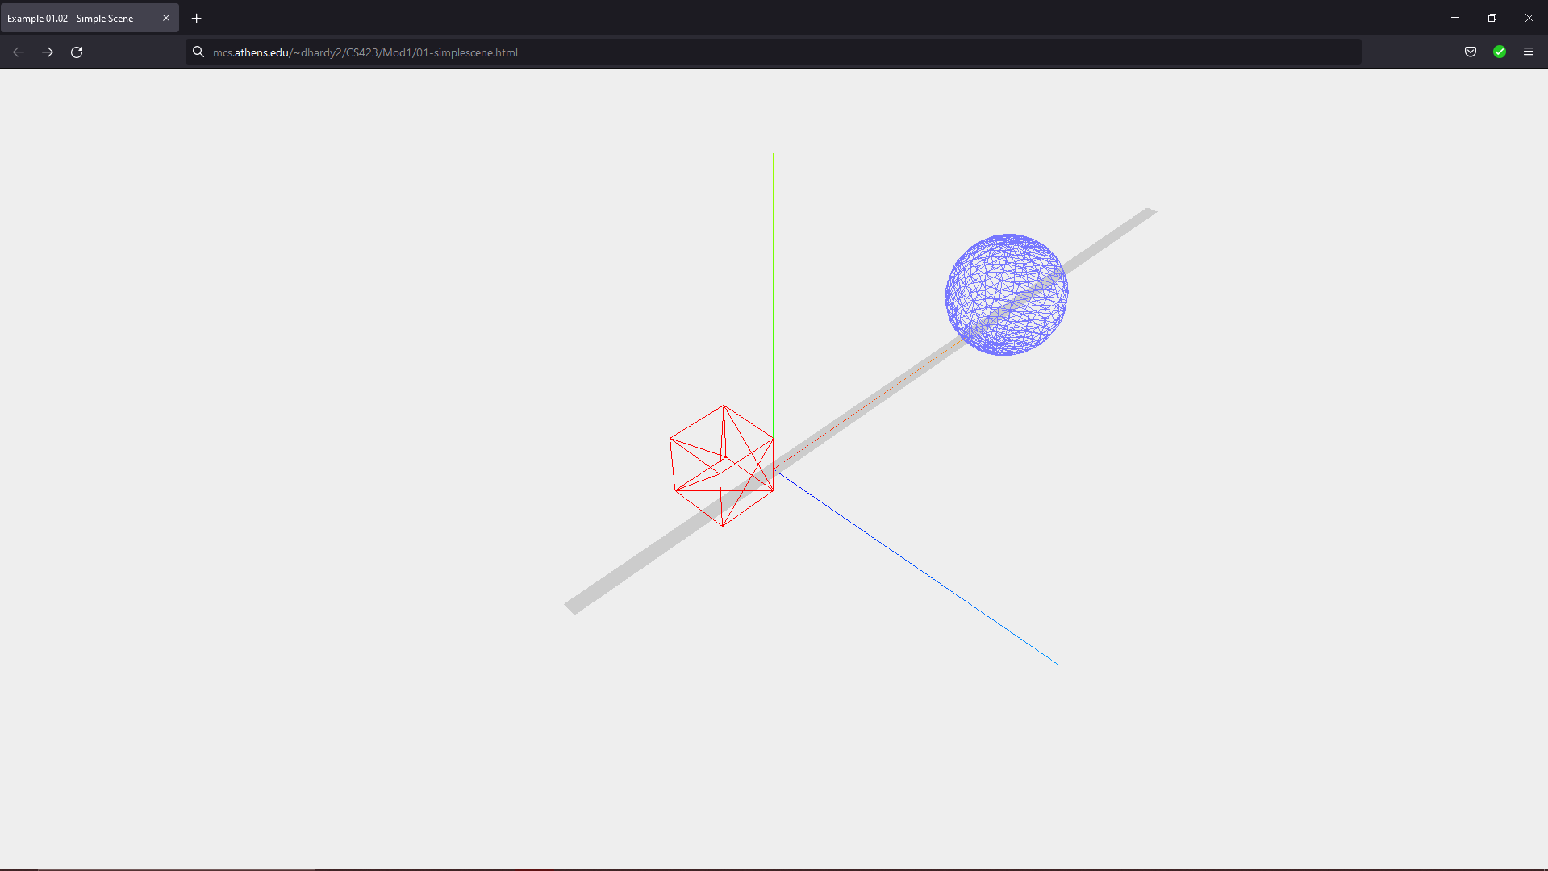

<!DOCTYPE html>

<!--File: 01-simplescene.html -->

<html>

<head>

<title> Example 01.02 - Simple Scene </title>

<script

TYPE ="text/javascript"

SRC="../libs/three.js">

</script>

<style>

body {

/\* set margin to 0 and overflow to hidden, to go fullscreen \*/

margin: 0;

overflow: hidden;

}

</style>

</head>

<body>

<div id="Stats-output"></div>

<!--Div which will hold the Output -->

<DIV id="WebGL-output"></DIV>

<!-- Javascript code that runs our Three.js examples -->

<script type="text/javascript" SRC="./01-simplescene.js"></script>

</body>

</html>

//

// File: 01-simplescene.js

// Purpose:

// Demo some of the basics of working wit the scenegraph.

// Thisis an extension of code from the Learning Three.js textbook

// once everything is loadded, we run our Three.js stuff

function init() {

var scene = new THREE.Scene();

var extent = window.innerWidth / window.innerHeight;

var camera = new THREE.PerspectiveCamera(45, extent, 0.1, 1000);

var renderer = new THREE.WebGLRenderer();

renderer.setClearColor(0xEEEEEE,1.0);

renderer.setSize(window.innerWidth,window.innerHeight);

// Drop a axis set into the scene

var axes = new THREE.AxisHelper(20);

scene.add(axes);

// Let's add a base plane upon which we place objects.

var planeGeometry = new THREE.PlaneGeometry(60.20);

var planeMaterial = new THREE.MeshBasicMaterial({color:0xCCCCCC});

var plane = new THREE.Mesh(planeGeometry, planeMaterial);

plane.rotation.x = -0.5 \* Math.PI;

plane.position.x = 15;

plane.position.y = 0;

plane.position.z = 0;

scene.add(plane);

// Add a cube

var cubeGeometry = new THREE.BoxGeometry(4,4,4);

var cubeMaterial = new THREE.MeshBasicMaterial({color: 0xFF0000, wireframe: true});

var cube = new THREE.Mesh(cubeGeometry, cubeMaterial);

cube.position.x = -4;

cube.position.y = 3;

cube.position.z = 0;

scene.add(cube);

// Add a sphere

var sphereGeometry = new THREE.SphereGeometry(4, 20, 20);

var sphereMaterial = new THREE.MeshBasicMaterial({color: 0x7777ff, wireframe: true});

var sphere = new THREE.Mesh(sphereGeometry, sphereMaterial);

sphere.position.x = 20;

sphere.position.y = 4;

sphere.position.z = 2;

scene.add(sphere);

//Need to tell Three.js the point from where we're viewing the scene

camera.position.x = -30;

camera.position.y = 40;

camera.position.z = 30;

camera.lookAt(scene.position);

//Now update the page by attaching the renderer to appropriate place in the

// HTML DOM for a page and then tell the renderer to render the scene

document.getElementById("WebGL-output").appendChild(renderer.domElement);

renderer.render(scene,camera);

}

window.onload = init;

Files not included three.js